**SER Assignment: Activity Diagrams**

## Procedure

For this assignment you will need to produce two activity diagrams based on specification described in two use cases.

* **Step 1:**Evaluate the use case diagram and the two use case specifications (included below).
* **Step 2:** Create a two activity diagrams one for each of the two use case specification.

# Use Case Diagram

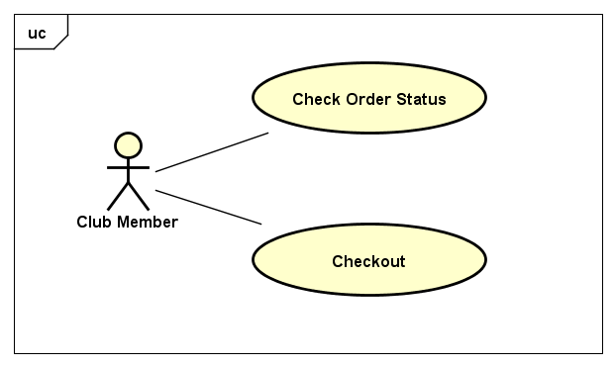

# Glossary

## Club Member

The Club Member is described as someone who has a valid CustomerID and password on file with Classics Inc.

## Catalog

The catalog includes all CDs that are available for sale on the ClassicsCD.com Web site.

## CustomerID

The customerID is used to identify Club Members.

## Shopping Cart

The shopping cart is the generic term for the container of all items that have been selected for purchase.

# Use Case 1: Check Order Status

**Objective:** ClassicsCD.com members view the status of their orders.

**Preconditions:**

* User must already be a valid member of ClassicsCD.com with a CustomerID and Password.
* User must have a previously completed order.

**Postconditions:** *None*

**Primary Actor:** Club Member

**Secondary Actors:** *None*

**Trigger:** User checks status of a previous order by having user select “view status” action on the website.

## MAIN SUCCESS SCENARIO

1. User checks status of a previous order by having user select “view status” action on the website.
2. If the user already has an authenticated session go to step 5.
3. The system shall display a page on which the user enters his or her CustomerID and Password.
4. The system validates the credentials and creates an authenticated session.
5. The system shall display a list of all orders placed by this user; the system sorts the list in ascending order by the order number.
6. To see the details of a specific order, the user selects an OrderID.
7. On the Details page, the user clicks a Title to see details of a particular item. Item details include:
   * Picture of the cover
   * CD Title
   * Price
   * Performer and Orchestra
   * Review of the CD
8. The use case ends when the user leaves the Details page.

## FAILURE SCENARIOS

1. User enters an invalid CustomerID and/or Password in step 3
   1. If the user enters an invalid CustomerID and/or password, the system displays a message indicating that the CustomerID/Password combination is not valid.
   2. The user is given an option to return to the CustomerID/Password entry page.
2. No order
   1. If the user has no past orders the system displays a corresponding message. The use case ends.

# Use Case 2: Checkout

**Objective:** ClassicsCD members want to buy the CDs they have added to their shopping cart.

**Preconditions:**

* User must already be a valid member of ClassicsCD.com with a CustomerID and Password.
* User must have added at least one item to the shopping cart.

**Postconditions:** The order is in the fulfillment system.

**Primary Actor:** Club Member

**Secondary Actors:** *None*

**Trigger:** User selects “checkout” functionality from the User Interface of the ClassicsCD.com website

## MAIN SUCCESS SCENARIO

1. User selects “checkout” functionality from the User Interface of the ClassicsCD.com website
2. If the user already has an authenticated session go to step 5.
3. The system shall display a page on which the user enters his or her CustomerID and Password.
4. The system validates the credentials and creates an authenticated session.
5. The system displays a summary of items in the shopping cart, including the following details from the user’s membership records:

* Shipping address
* The last four digits of the member’s credit card
* An estimate of when Classics will ship the product.
* The total amount that Classics will charge to the member’s credit card.

1. The user enters his or her e-mail address.
2. The user completes the order.
3. The system confirms the order.
4. If the system is able to complete the order immediately, then the system displays a confirmation that the order has been placed and provides an order number for reference. Otherwise, the system indicates that the user will receive an e-mail when the order is completed.
5. The use case ends when the user leaves the order confirmation page.

## FAILURE SCENARIOS

1. User enters an invalid CustomerID and/or Password in step 3
   1. If the user enters an invalid CustomerID and/or password, the system displays a message indicating that the CustomerID/Password combination is not valid.
   2. The user is given an option to return to the CustomerID/Password entry page.
2. Empty cart
   1. If the user’s shopping cart is empty, the system displays a message indicating that user has not selected any items to purchase. The use case ends.